**Q1. What is SDLC (software development life cycle)**

The process of planning, implementation, testing, documentation, deployment, maintenance &support is called SDLC.

it provides a model for development &lifecycle management of an application or piece of software

**Q2. What is Software testing**

It is a process used to identify the correctness, completeness, & quality of developed computer software is called software testing.

**Q3. Write-down SDLC phases with basic introduction**?

Following are the SDLC phases-

1. Requirement gathering-
2. Analysis
3. Design
4. Implementation
5. Testing
6. . Maintenance
7. **Requirement gathering**

Requirements documented in written form, they may be incomplete, unambiguous, even incorrect form. requirement will change.

Three types of requirement are present-

1. **Lack of clarity-**

It is hard to write-down documents that are both precise and easy to read.

1. **Requirement confusion**-

Functional & nonfunctional requirement tends to be intertwined.

1. **Requirement ambulation**-

Several different requirements may be expressed together

**2.Analysis phase**

Analysis phase defines the requirements of the system, independent of how these requirements will be accomplished

3.**Design phases**

-Design architecture document

-Implementation plan

-Critical priority analysis

-performance analysis

-Test plan

**4.Implementation Phase-**

**In this phase, team build the compon**ents either document from the design phase requirement document from the analysis phase, the team should build exactly what requested through there is still room for innovation &flexibility.

**5.Testing phase**

quality is very important in many company boz of this testing each component is very important

**6.Maintanance-**

Repair defects &adapt the solution to the new quirements.

Following3 are the maintenance types

a. Corrective Maintenance

adaptive Maintenance

perfective Maintenance

**What is agile methodology?**

Agile SDLC model is a combination of iterative & incremental process models with focus on process adaptability &customer satisfaction by rapid delivery of working software product.

It breaks the product into small incremental builds.

These builds are provided in iteration.

Each iteration last in 1to 3 weeks.

Every iteration involves planning, requirements analysis, design, coding, unit testing, &acceptance testing.

**What is srs**?

It is complete behavior of the system to be developed.

It includes set of use cases which describe all of iterations that the users will have with the software.

Use cases known as functional requirements.srs also contains non fictional requirements.

non-functional requirements which impose constraints on the design or implementation.

standards describe possible structure, desirable contents, qualities of software requirements specification.

-there are 3 types of requirements

1.customer requirements.

2.funcational requirements.

3.non-funcational requirements.

**What is oops?**

Identifying objects &assign responsibilities to these object.

objects communicate to other objects by sending messages.

messages are received by methods of an object.

object is like black box.

internal details are hidden.

objects are derived from obstruct data type.

objects of a program interact by sending messages to each other.

**concept of OOPS**

**-object**

**-**class

-Encapsulation

-Inheritance

-Polymorphism

-Abstraction

**What is object?**

It represents individually item, unit, entity, either real or obstruct, with well-defined role in the problem domain.

This is the basic unit of oop.

That is both data & function that operate on data are bundles as a unit called as object.

Object=Data Method

**What is class?**

It is collection of data member(variable)& member function (process methods) with its behaviors

when u define class then u define blueprint for an object.

class represents an obstruction of the object& abstract the properties& behavior of that object.

sy:

class class name

data member;

member function;

**What is encapsulation?**

Encapsulation in java is the process of wrapping up of data & behavior of an object into single unit; & unit here is a class.

in java everything is enclosed within a class or interface, unlikelangauges such as C&C++, where we can have global variables outside classes.

It enables data hiding, hiding irrelevant information from the users of class exposing only relevant details required by the users.

**What is Polymorphism?**

Ability to take one name having different forms.

: many forms /multiple forms.

It allows different objects to respond to the same messages in different ways, the response specific to the type of the object.

The ability to change form as polymorphism.

There are 2 types of polymorphism in java

1.Compile time polymorphism(overloading).

2.Run time polymorphism(overriding).

**What is inheritance?**

It means properties of parent class extends into child class.

main purpose is reusability, extendibility.

: there are mainly 5 types

1.single

2.multilevel

3.inheritical

4.multiple:java does not support

5.Hybrid:java does not support

**Write phases of spiral model?**

It is widely used in software industry; it is synch with the natural development process of any productive. learning with maturity & also involves minimum risk for the customer as well as development firms.

**pros -**

-changing requirement can be accommodated.

-allows extensive use of prototypes.

-Users see system early.

-requirements capture more accurately.

**cons-**

-management is complex.

end of project not know.

spiral may go indefinitely.

process is complex.

**following are the usages of spiral model-**

-used for medium high -risk projects

-Requirements complex &need evolution to get clarity.

-significant changes are expected in the product during the development cycle.

-long-term project commitment

**Write agile manifesto principles?**

**1.**Individual interaction

2.working software

3.coustemer collaboration

4.responding to change.

**Q. Explain working methodology of agile write pro & cons of agile?**

it is a combination of iterative & incremental process models with focus on process adaptability & customer satisfaction by rapid delivery of working software product.

Agile methods break product into small incremental builds.

These builds provide into iteration.

**Pros**

very realistic approach to software development.

Requires minimum resources.

suitable for fixed & suitable changes.

Delivers early partial working solution.

Good model for environments that change steadily.

**Cons-**

Not suitable for handling complex dependencies.

more risk for sustainability, maintainability, extendibility.

transfer of technology to new members quietly challenging due to lack of documentation.

high individual dependency.

depends on customer interactions.

**What is waterfall model? Write pros cons of waterfall model?**

**-**The classical software lifecycle models, the software development as a step by step ''waterfall mode" between the various development phases.

Waterfall is unrealistic for many reason especially-

Requirements must be frozen to early in the lifecycle.

Requirements validated too late.

**Application**

-Requirements are very well documented, clear& fixed.

-Product definition is stable.

_Technology is understood is not dynamic.

-There are no ambiguous requirements.

The projects are short.

**Pros-**

-Simple &easy to understand& use.

-Clearly defined stages.

-well understood milestones.

-Easy to arrange task.

Process & results are well documented.

**Cons-**

-No working software is produced until late during the lifecycle.

-High amount of risk &uncertainty.

-Not good model for complex &object oriented projects.

-Poor model for long & ongoing projects.

-IT is difficult to measure progress within stages.

-Cannot accommodate changing requirements

Draw use case on online bill payment system (paytm)?

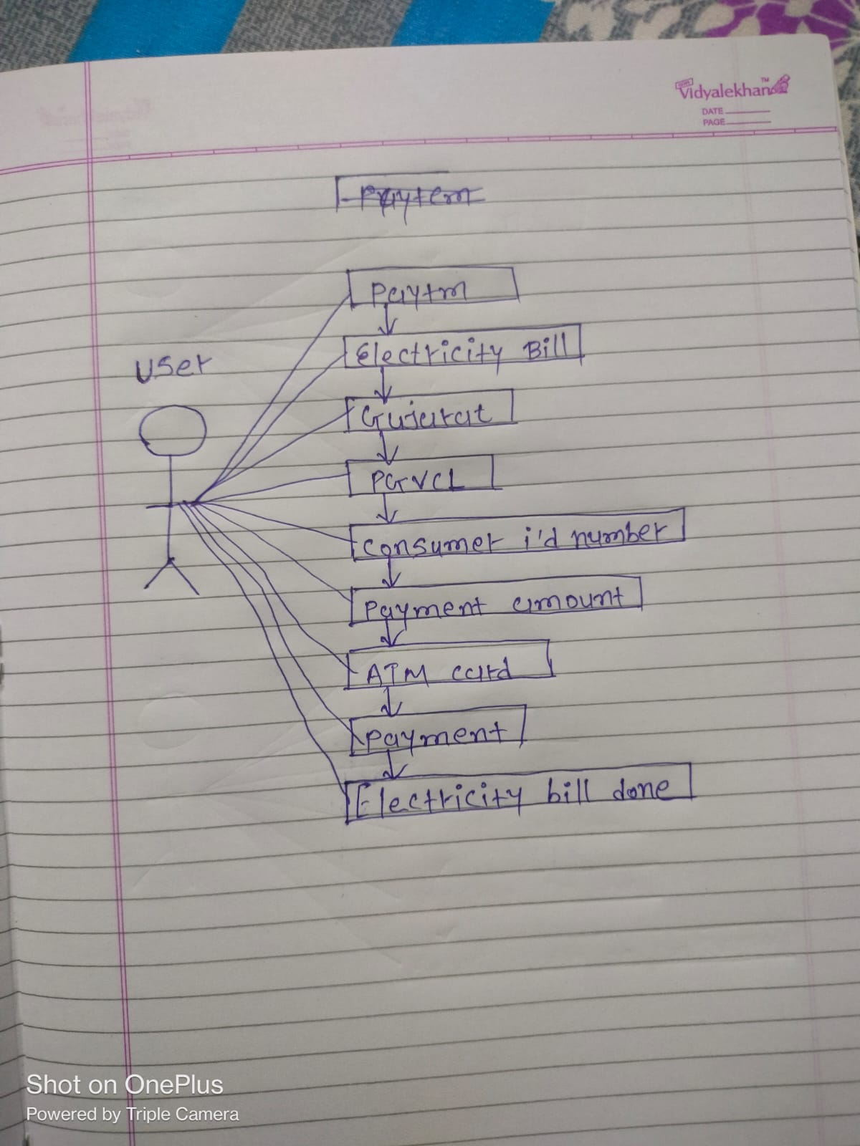

Draw use case on online book shopping?

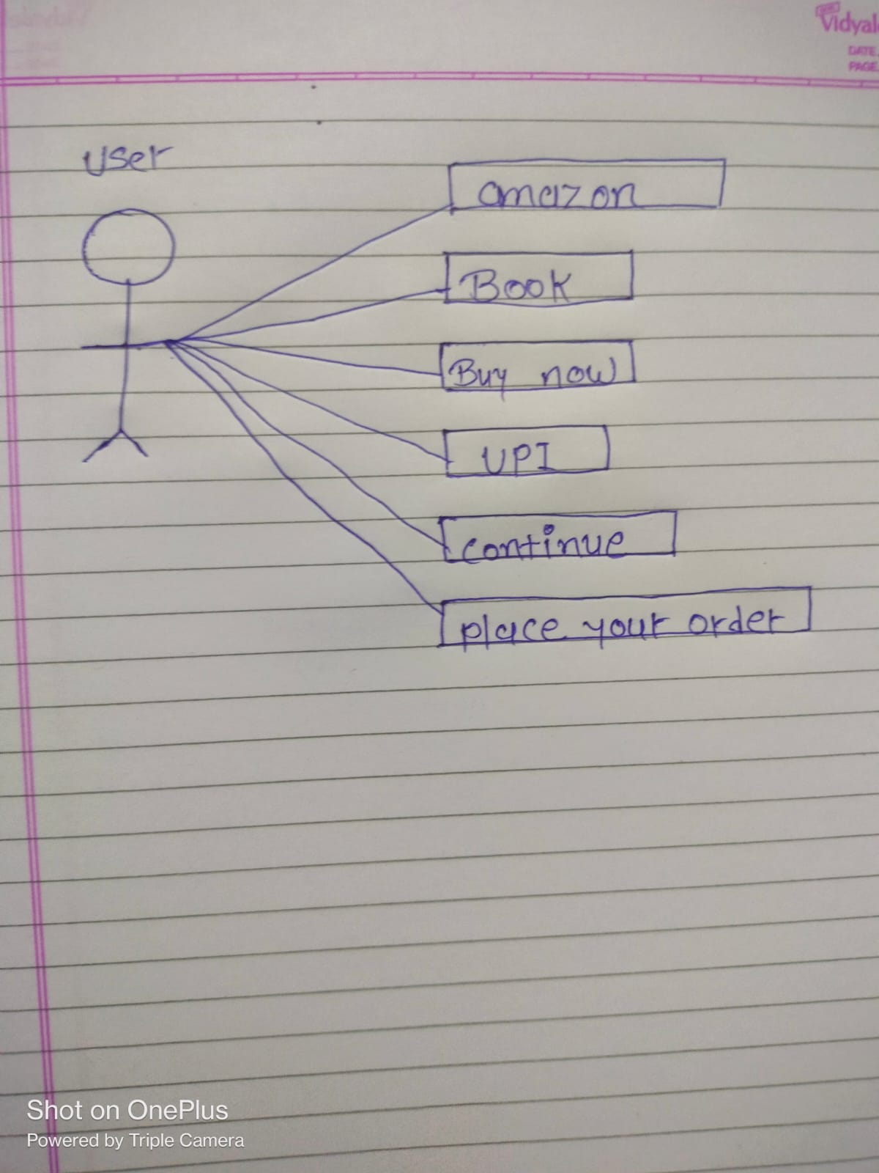

Draw use case on online shopping product using cod?

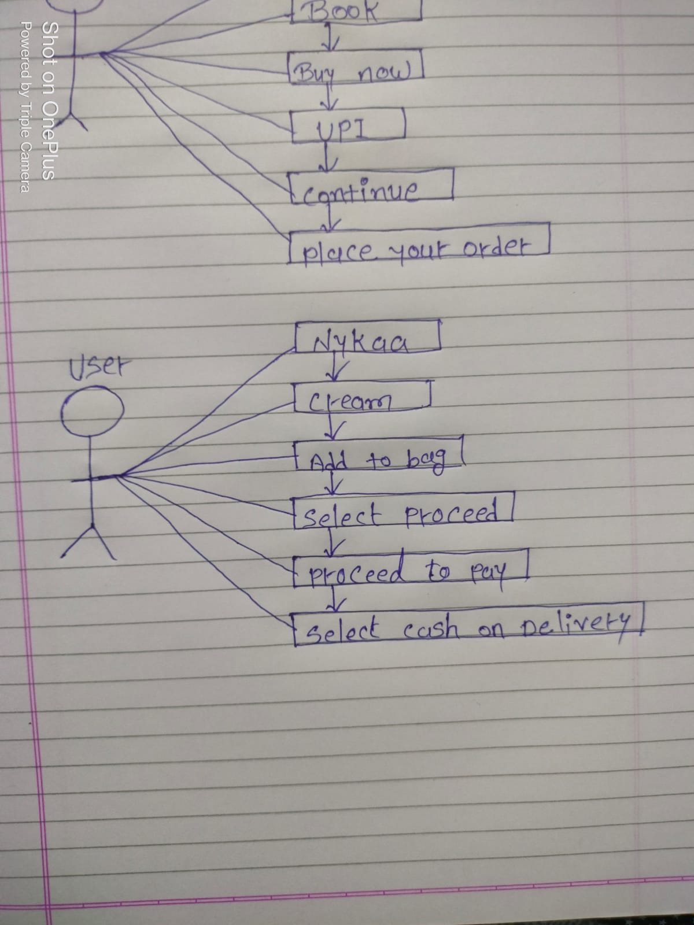

Draw use case on online shopping product using payment gateway?

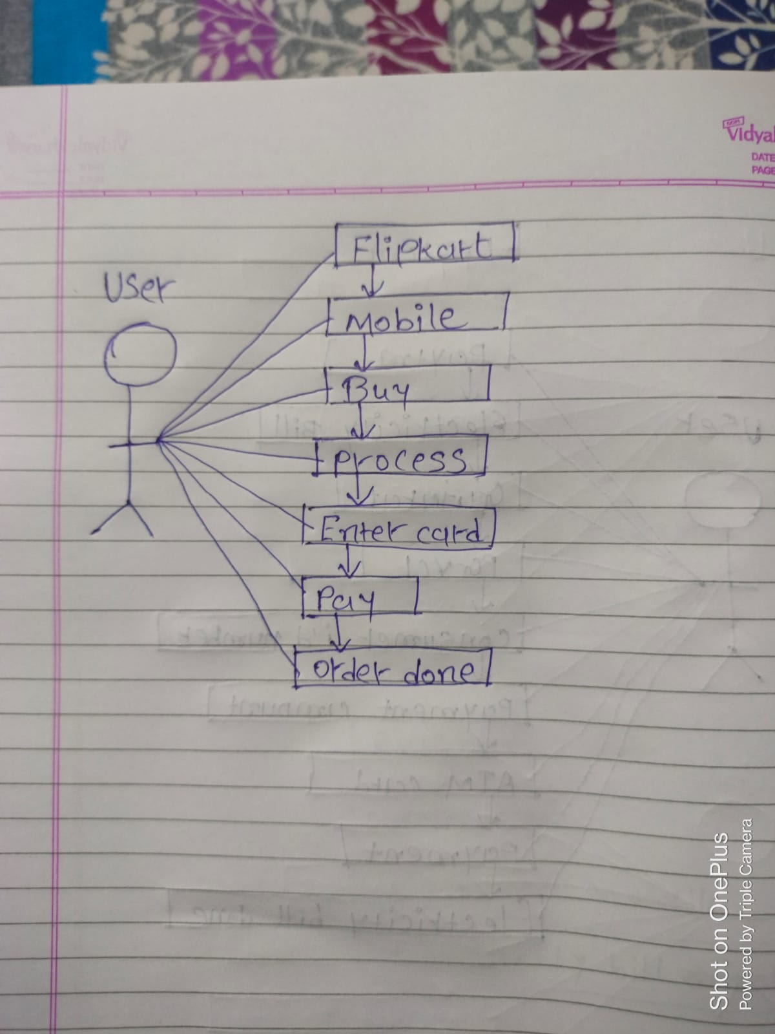ss